Go to <https://meldmerge.org/> and download, then install

**First option:**

git config --global merge.tool meld

git config --global diff.tool meld

git config --global mergetool.meld.path “D:\Program Files (x86)\Meld\meld\meld.exe”

**Second option:**

Open git bash and write:

git config --global --edit

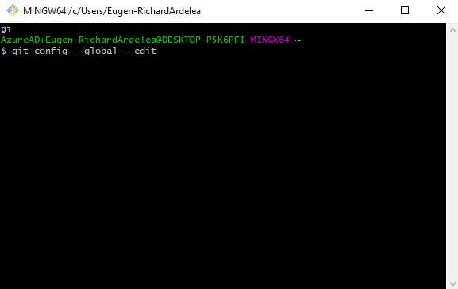

This will open the .gitconfig file, which should look something like this:

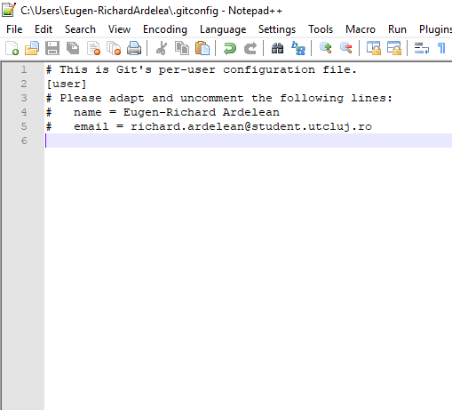

Next step is to write the following lines:

[merge]

tool = meld

[mergetool "meld"]

cmd = meld "$LOCAL" "$MERGED" "$REMOTE" --output "$MERGED"

path = C:\\Program Files \\(x86\\)\\Meld\\meld\\meld.exe

[diff]

tool = meld

Save the file and close.